How to Restore Aluminum Wheels

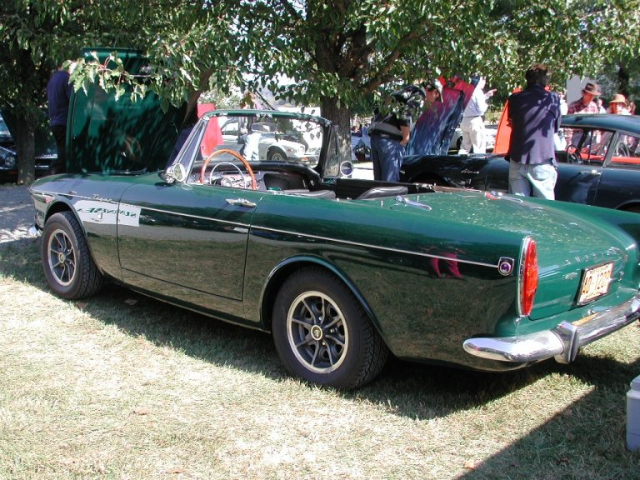
Joe Parlanti
B382000026

While we all know that Tigers did not arrive from the factory with aluminum wheels, many of us have cars with aftermarket or LAT optioned wheels which may at some point need to be renewed. This article will outline a process I used to restore my wheels but will work on virtually any type of wheel, even the stock steel ones.

The wheels I have were made by Dunlop and even though they are 13”, I have always had a desire to keep them because they are period correct for the car, and not seen very often on Tigers. I have run across a couple cars with them and interestingly enough each had a different center color treatment; natural aluminum, black, and mine which are a gun metal grey metallic. As an interesting aside, I asked Norm Miller about these wheels which were on another Tiger I had many years ago and was regaled with this story. Apparently, Dunlop had gone to Sunbeam to sell these wheels for the Tiger but for one reason or another, the deal fell through. There is a rumor that a couple of the cars made it off the assembly line with these wheels installed. Knowing how Sunbeam used whatever parts happened to be in the bin at the time of assembly, one never knows. Unfortunately, there have never been any photographs or other documentation to substantiate the rumor, so for now it remains an interesting side note to the Sunbeam story.

So now let’s dive into the techniques I used to restore my wheels. As I mentioned before, any of these procedures can be used on other wheels by substituting other colors, or finishes. The basis of my restoration centers around my favorite finishing process, powder coating. I use the Eastwood powder coating gun and have written another article about the general process if more detail is desired.

Cleaning the wheels

I chose to media blast my wheels with glass beads which worked very well. The center of the wheels had been painted a gun metal grey color which came off readily. I did protect the polished aluminum areas with masking tape during the blasting process. After that I degreased them in preparation for the powder coating process.

One issue that arises when powder coating cast aluminum parts, is that it tends to off-gas under elevated temperatures during the curing process. This can leave small bubbles and imperfections in the finish if not prepared properly. The solution is simple, before applying powder, place the part in the oven at the flow-out temp, usually around 400 deg. F, for 1-2 hours. I usually add 10-20 deg. just to be safe. This will insure that all of the gas trapped in the metal will dissipate before applying the powder.

The final step was to polish all of the areas that were that way originally. In the case of my wheels, I went a bit further. The radial ribs were originally left in their rough cast form. I wanted them to be polished like the rim, so I ground them down slightly, followed by increasingly finer grades of sandpaper, and finally polishing to a high mirror finish. It was a lot of work, but I like the results.

First Application of Powder

After cleaning the wheels with acetone to remove any oils or contaminants, I masked the wheels so that I could coat the areas under the tire and on the inside of the wheel. I decided to use a silver powder for this stage. The key is to mask every hole that powder could make its way thorough to the other side. Here’s a shot of the finished step:

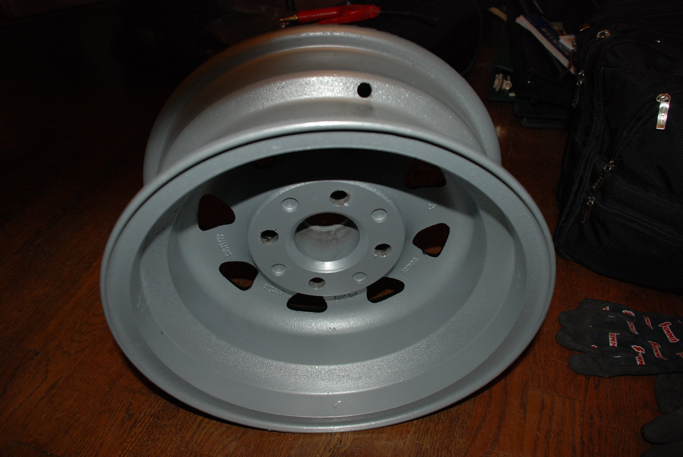

Second Application of Powder

This step involves applying the gun metal grey metallic powder to the inside of the wheel.

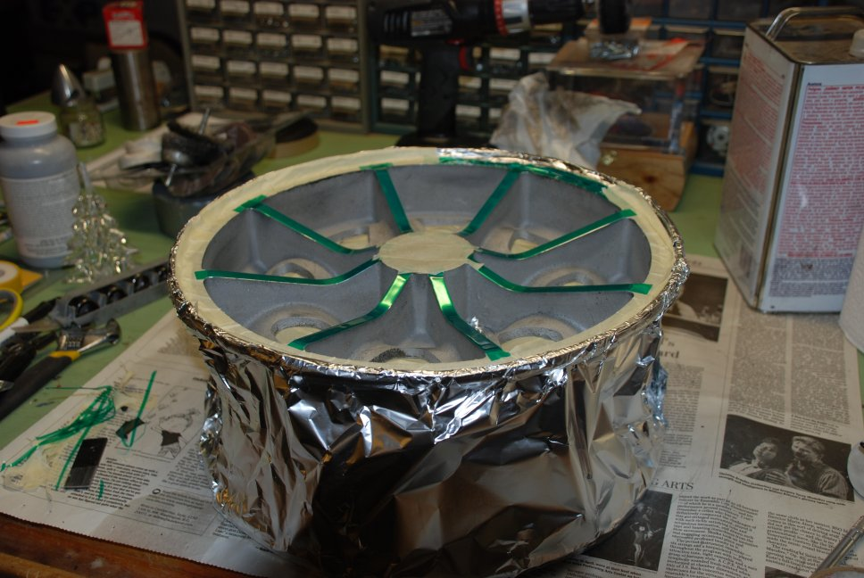
A large amount of masking must be done at this point to keep everything the correct color. Here are a couple of shots of the masking required:

You will notice several different methods for masking in these photos. For large areas, I use aluminum foil. It’s cheap and easy to mold around curves.

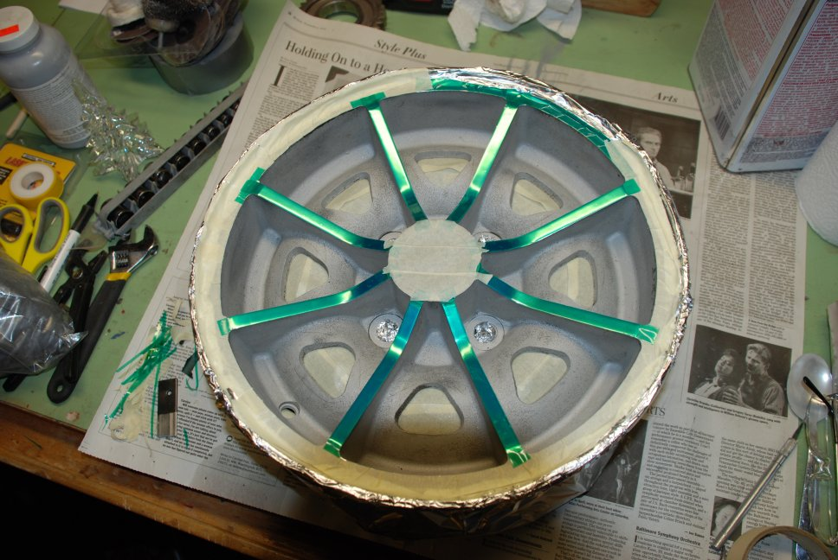
The yellow masking tape is actually a high temp tape that can be purchased from several sources. Eastwood sells it, but you can get it for about half the price from McMaster-Carr.

The green translucent tape was nice to use because it was easy to trim around the ribs and rim.

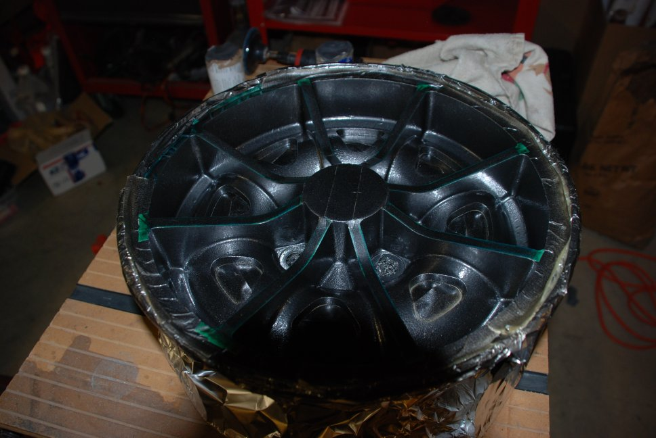
We’re now ready to add the gun metal color and go into the oven. Here’s the result:

Final Application of Powder

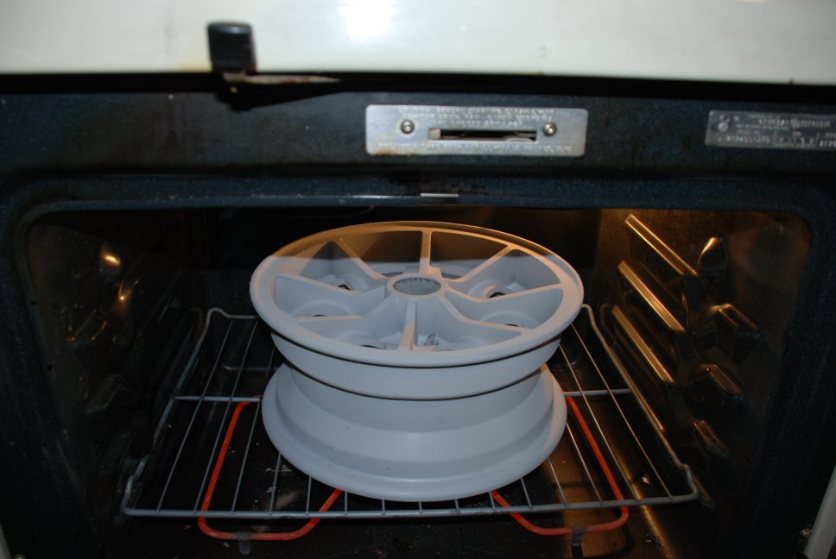
The final step in my restoration was to add a clear coating to the wheels. First remove all of the masking. I took this opportunity to clean up any “overspray” that may have made it past he masking tape onto the polished areas. This can be done with acetone and a lot of rubbing. As you can see, applying the clear powder leaves an opaque color before curing.

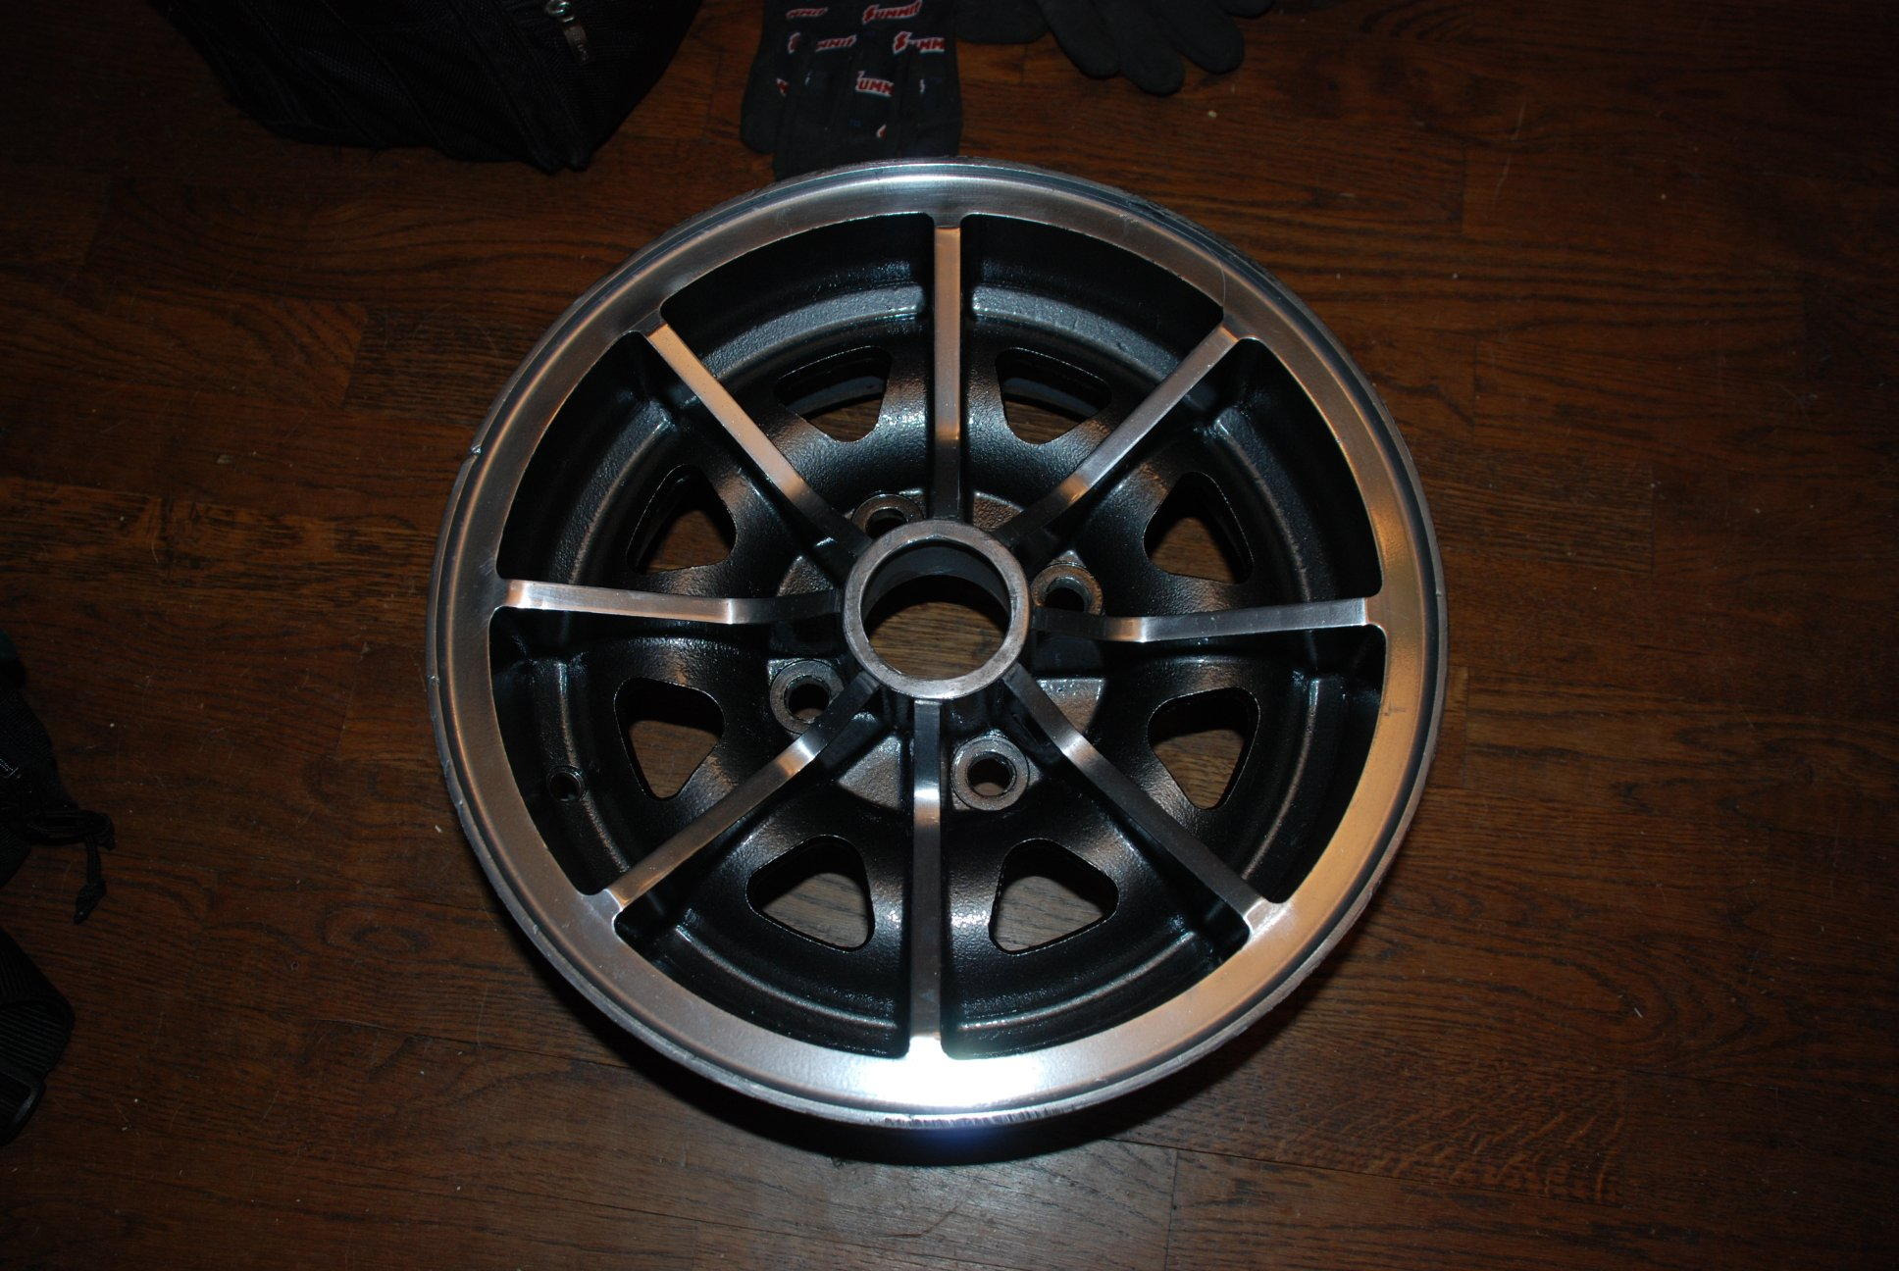
And now here’s the final result:

And a couple of shots back on the car:

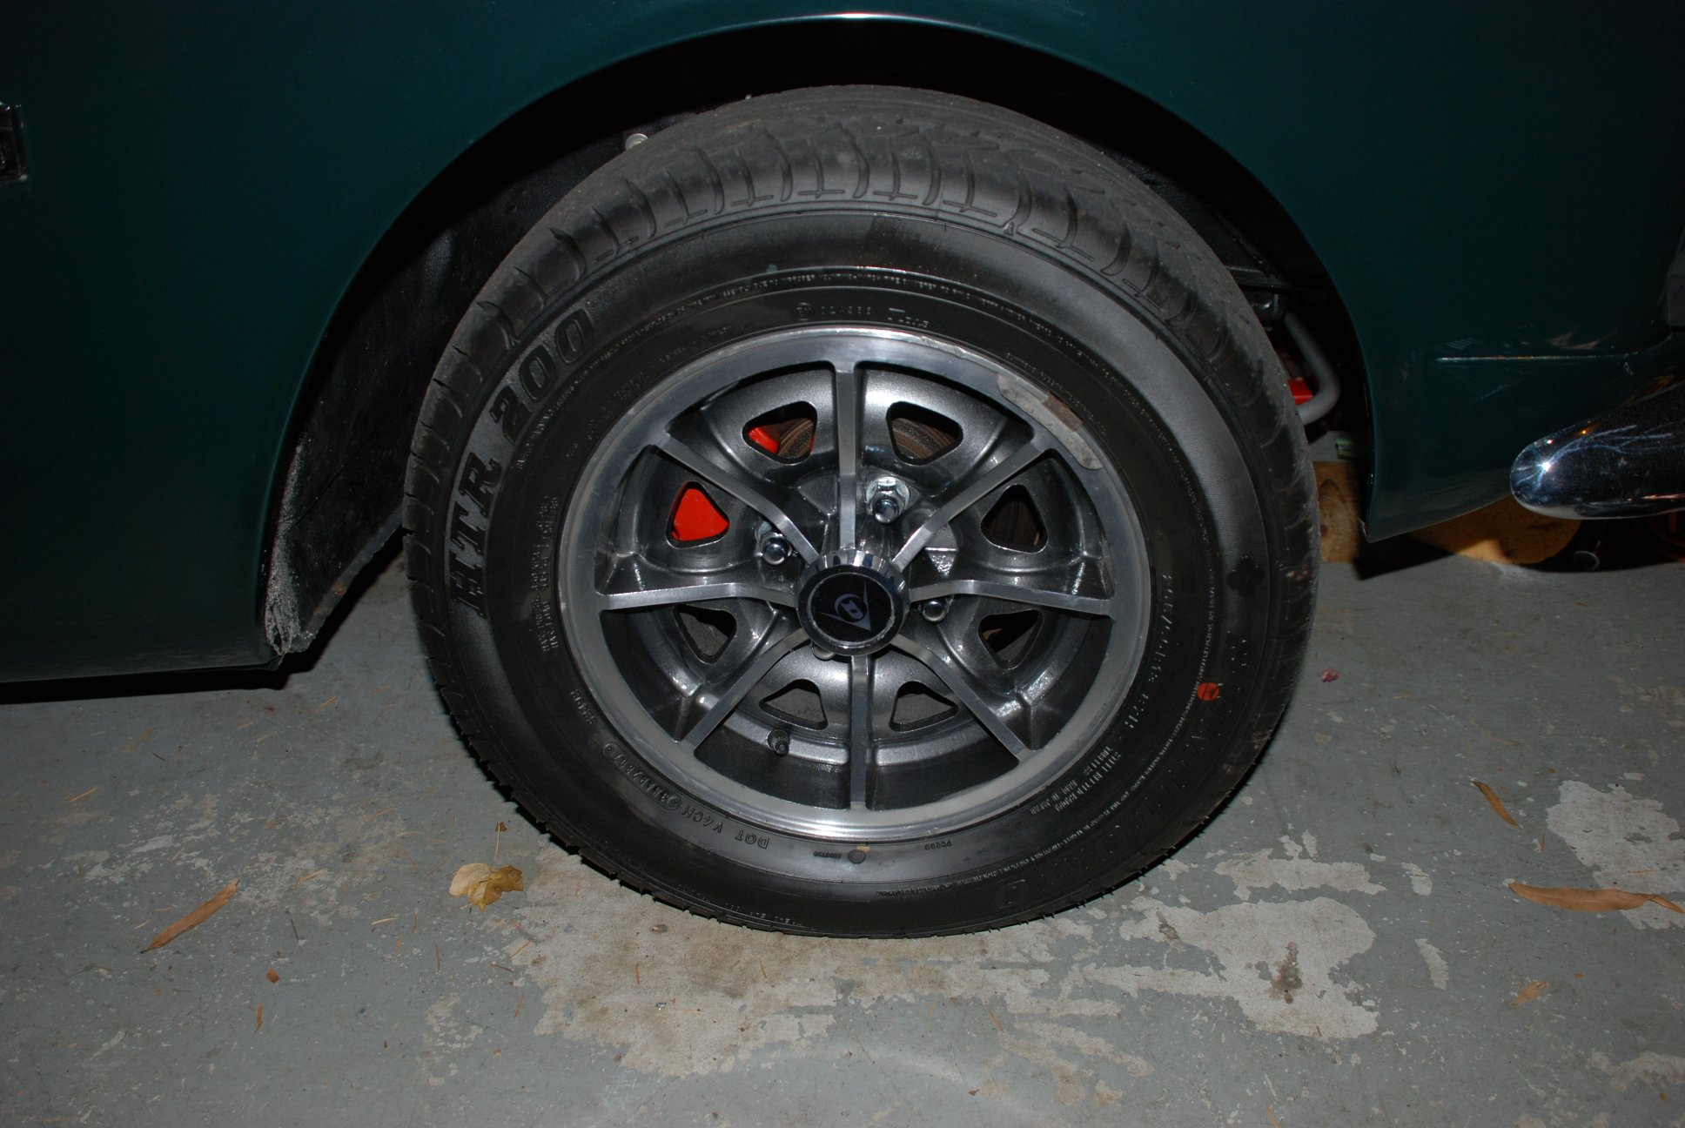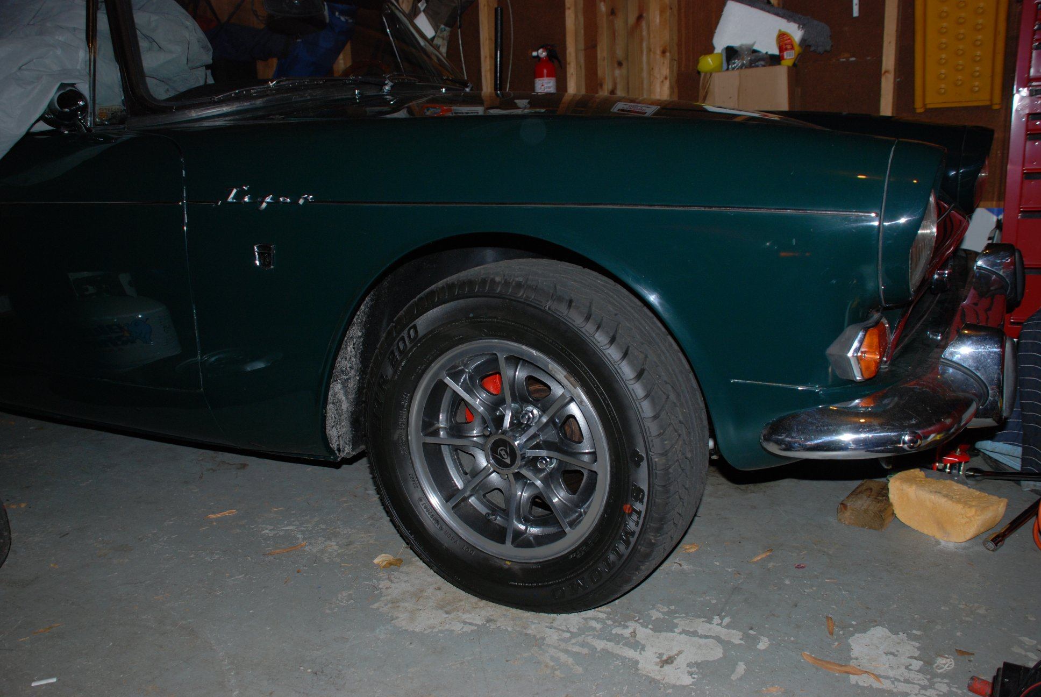

So there you have it! Why pay a wheel restoration company to do your aluminum wheels, when with a little effort, and a low cost powder coating system, you can achieve very nice results.

